Math 1 Name _________________________

**6-7 Triangle Proofs** Date _______

**Learning Goals:**

* I can use theorems, postulates, or definitions to prove theorems about triangles.

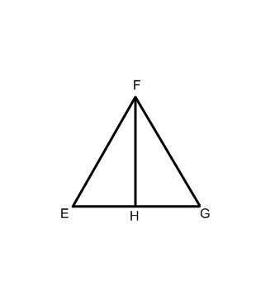

1. 



Statement Reason

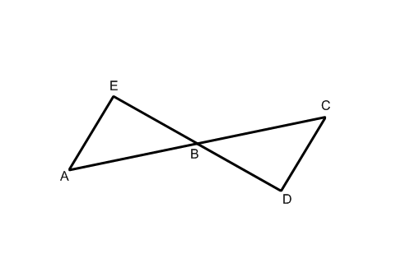

1. 



Statement Reason

1. 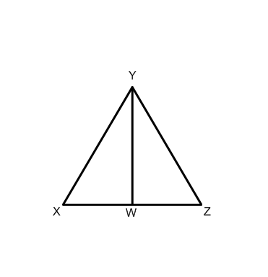



Statement Reason

1. 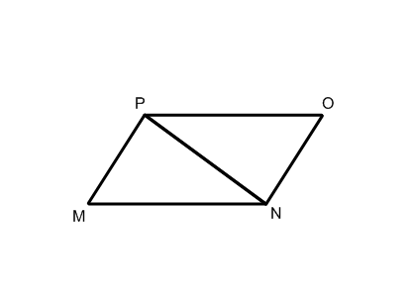



Statement Reason

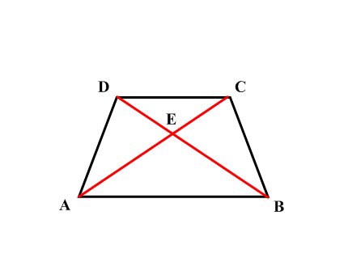5. Given:



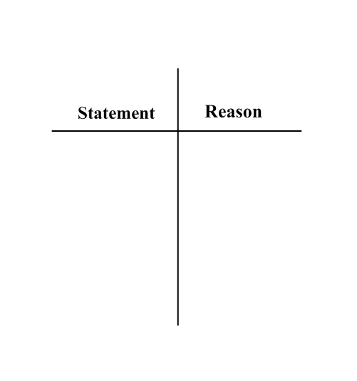 Prove: 

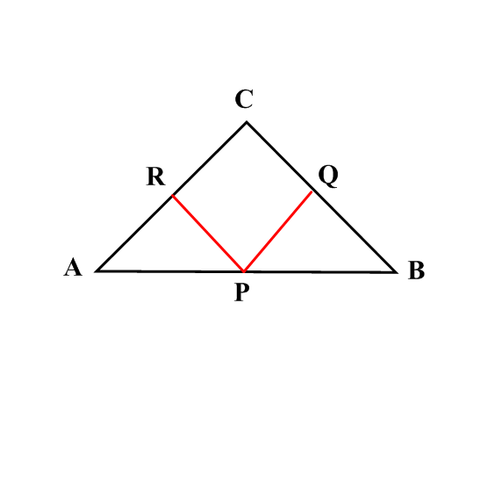6. 

 Prove: 

7. Given:



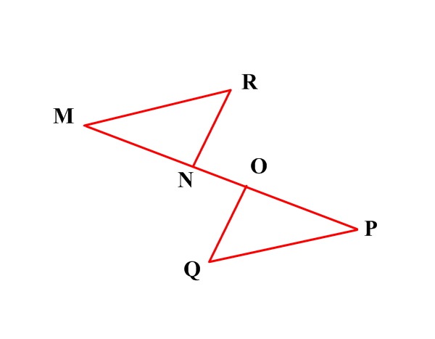

Prove: 



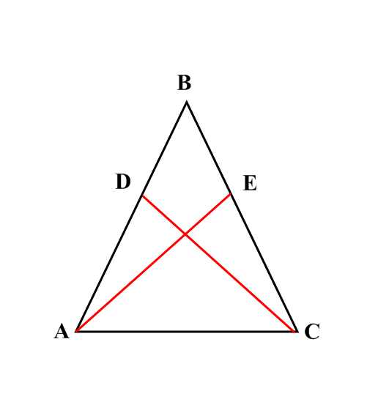

8. Given: 

 Prove: 

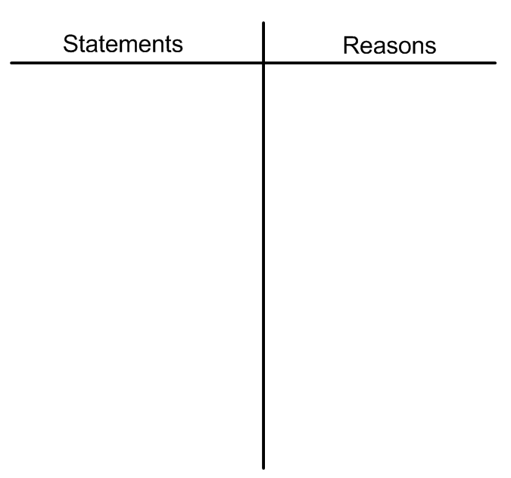9. Given: 

*Z* is the midpoint of 

Prove: 

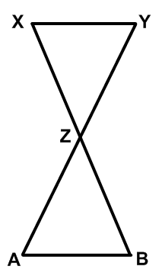



1. Given: 

bisects 

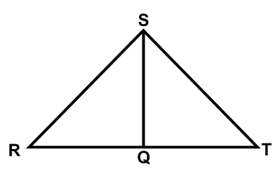 Prove: 



1. Given: 



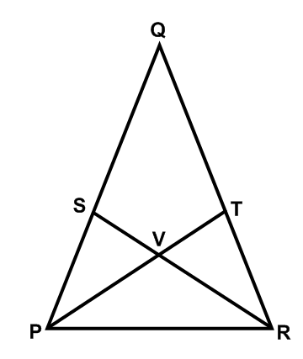 Prove: 